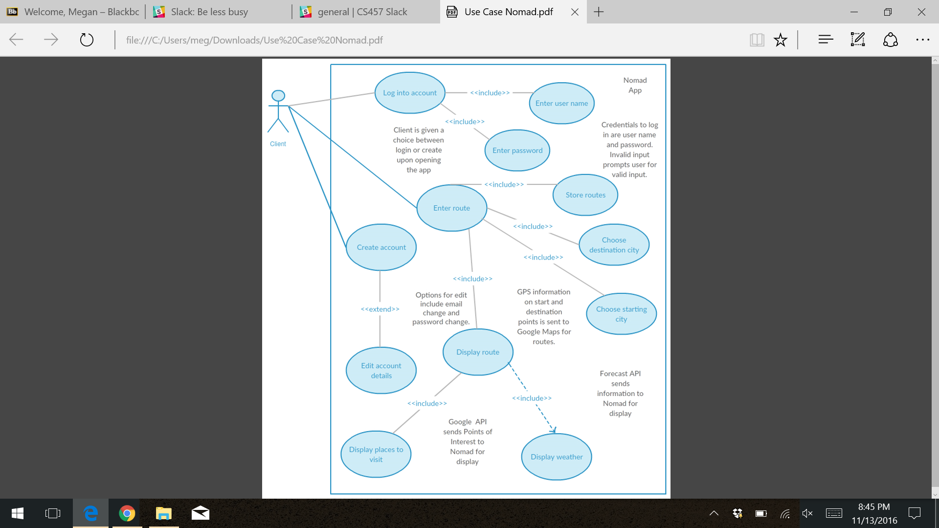

Activity diagram represents the standard events of the system:

-User will open the application, in which the system will require user to log in

-User will login, system will check for validity

-User will request route, system will determine route and return result to user

-Using gps and location services

-User will proceed to route, system will display weather along route and make sure user stays on path

-Weather will be updated each time user enters new city, using location services

-Using location services to make sure user is on route

-User will reach destination, system will store route in history and display places to visit at destination

-Using google places and location services

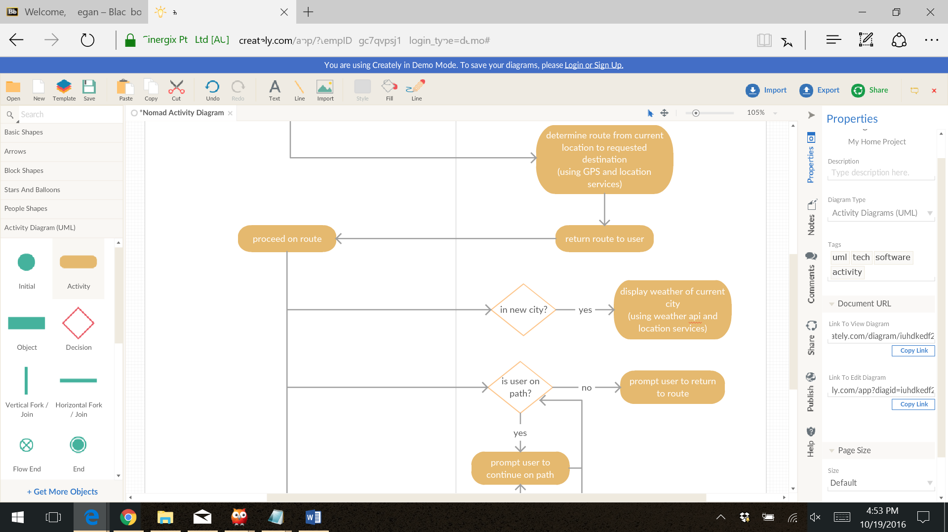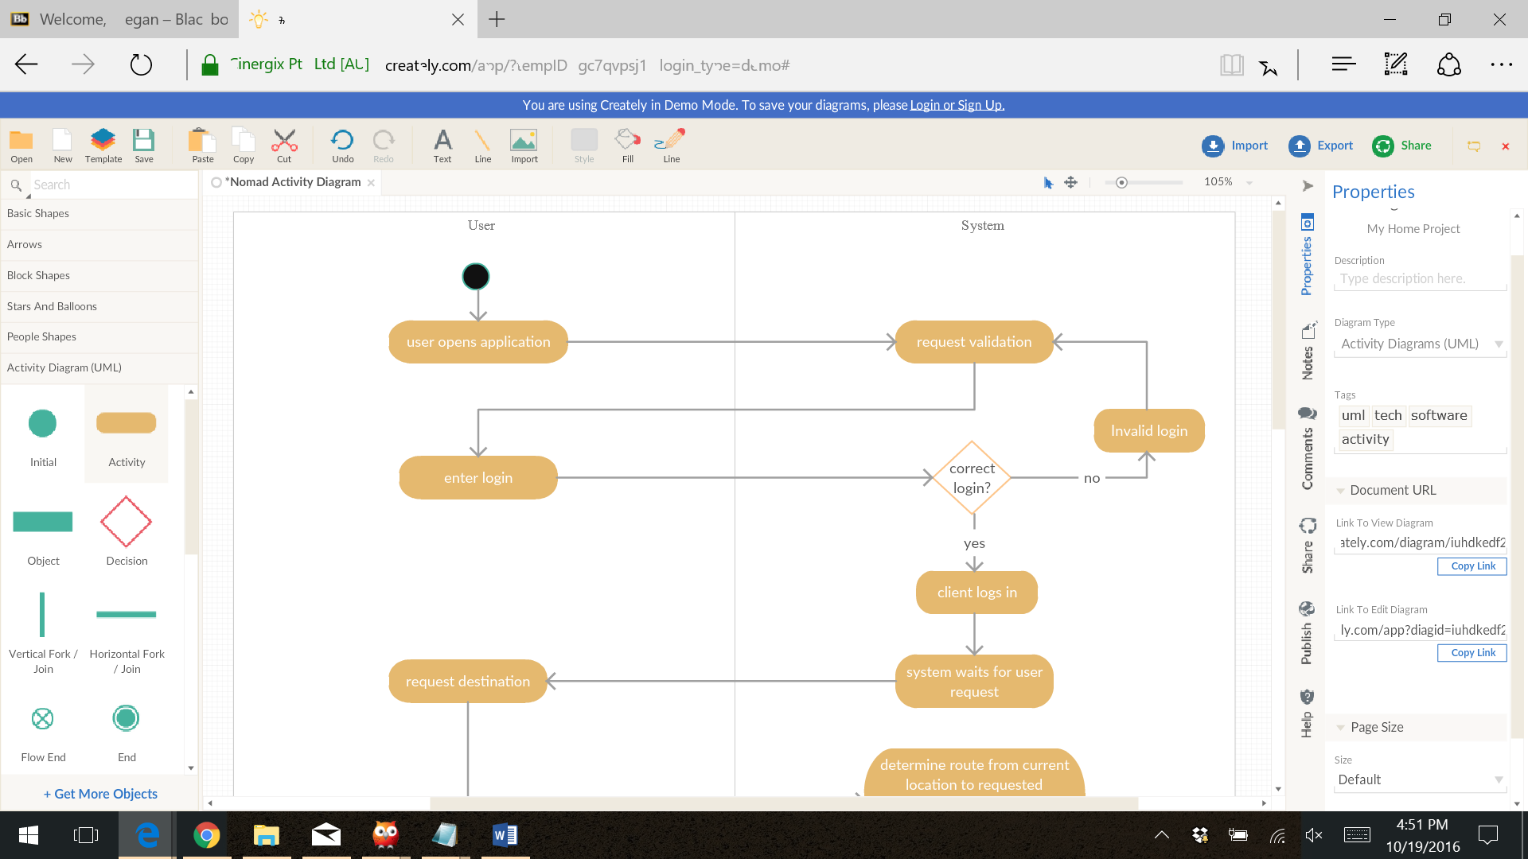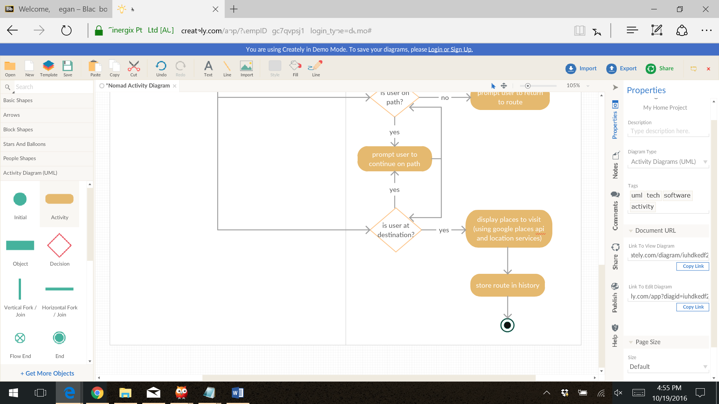

Use cases for sequence diagrams:

1. Route to destination
2. Display weather along route
3. Display places to visit upon arrival of destination
4. Prompt user to return to route if off route

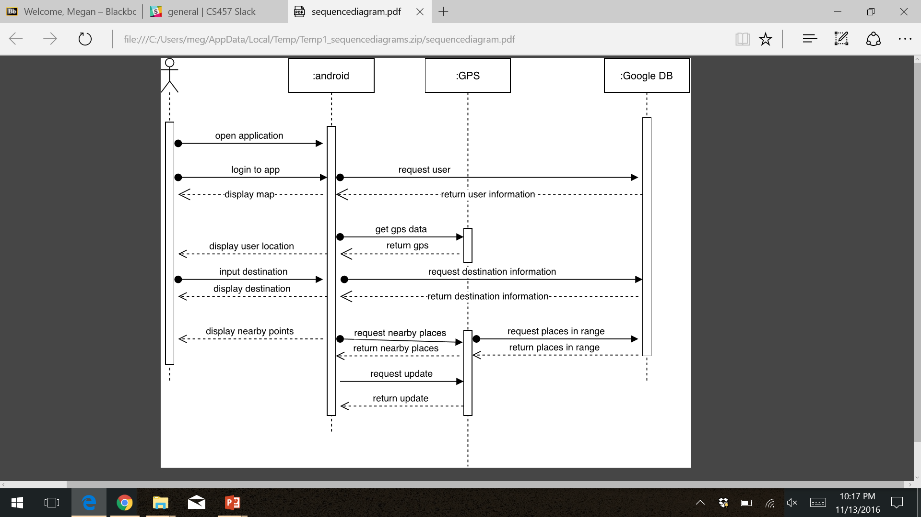

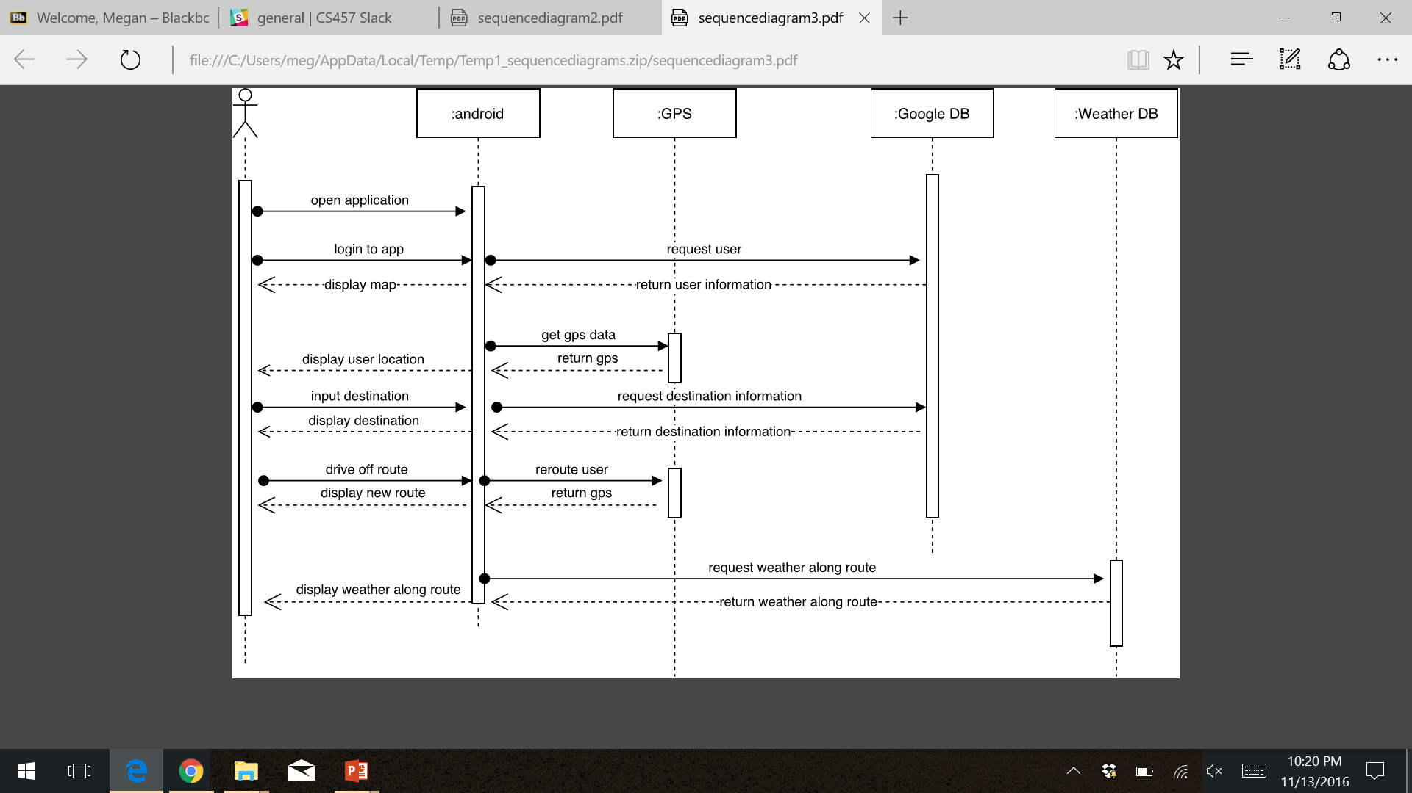

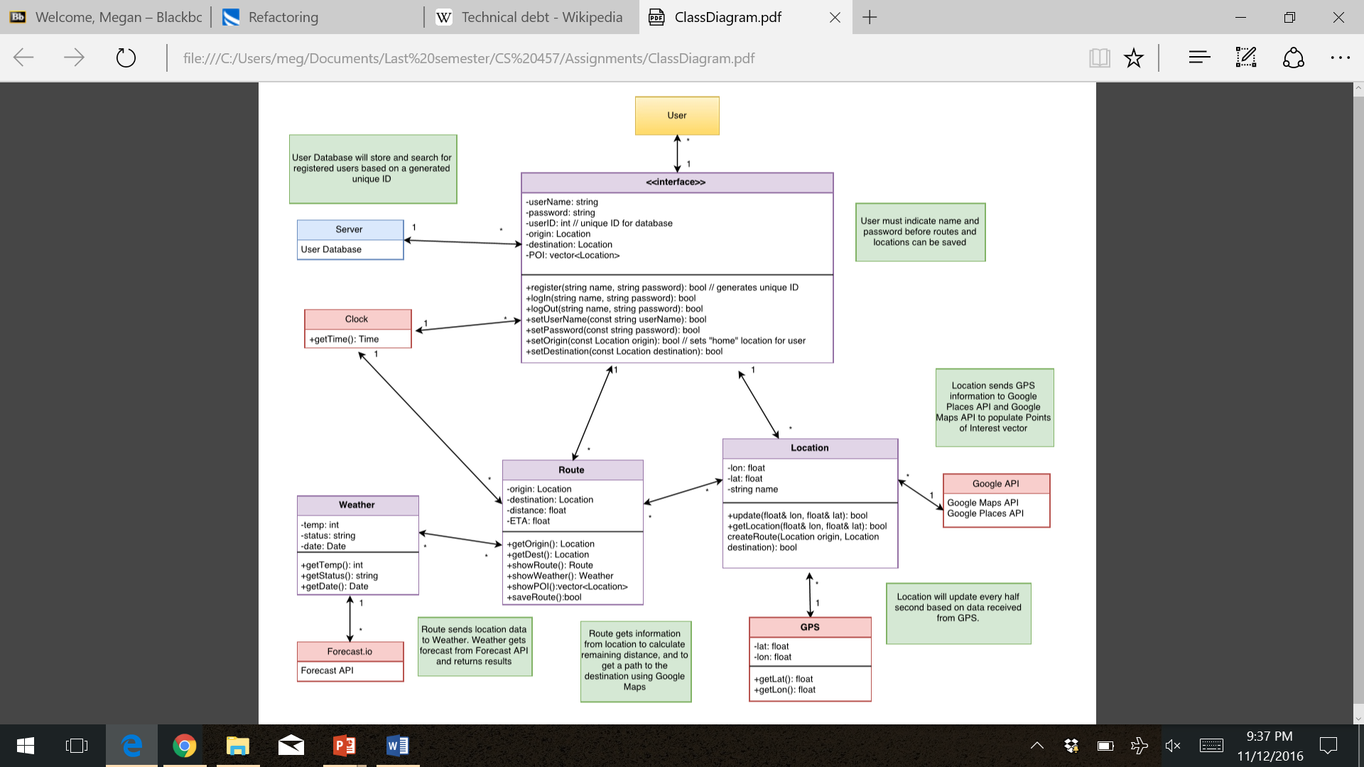

Design Pattern:

Observer Pattern

-Chose this pattern because system and user will need to notified when certain event occur during application execution

-Events such as:

-user veers off route and needs to return to correct path

-user enters new city and current weather needs to be updated

-user reaches destination and places to visit need to be displayed